9.9: a)
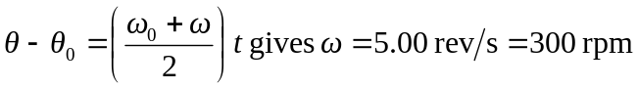
b) Use the information in part (a) to find
